# **Performance Analysis of Wireless Ad Hoc Networks using NetSim**

**Contents**

**Performance Analysis of Wireless Ad Hoc Networks using NetSim** 1

**Case 1: Single Link Networks: Proximity and Spatial Reuse** 3

**Procedure:** 3

**Network Scenario** 4

**Device Coordinates** 5

**Simulation Parameters** 5

**Static Route configuration** 6

**Results** 6

**Case 2: Ad Hoc Chain, Single Hop Communication: Two-Hop CS Range** 7

**Procedure:** 7

**Network Scenario** 8

**Device Coordinates** 8

**Simulation Parameters** 9

**Static Route configuration** 9

**Results** 10

**Plotting Average Throughput vs Number of Transmitting Nodes** 10

**Border effects in line networks: Plotting Throughput vs Transmitting Node ID** 12

**Case 3: Ad Hoc Lattice, Single Hop Communication, Two Hop CS Range: Horizontal Traffic** 15

**Procedure:** 15

**Network Scenario** 16

**Device Coordinates** 16

**Simulation Parameters** 17

**Static Route configuration** 17

**Results** 17

**Plotting Average Throughput vs Number of Transmitting Nodes** 18

**Case 4: 4 Hop Network** 20

**Using NetSim’s GUI. Importing the project into NetSim.** 20

**Simulation Parameters** 22

**Static Route Configuration** 23

**Numerical Results** 24

**Automated simulation using multi-parameter sweeper** 25

**Changes done to the config file to run the Multi-Parameter sweeper** 25

**Results** 28

**Case 5: 5 Hop Network** 30

**Additional Setting** 31

**Numerical Results** 31

**Changes done to the config file to run the multi-Parameter sweeper** 32

**Case 06: 6- Hop Network** 33

**Additional Setting** 33

**Numerical Results** 34

**Changes done to the config file to run the multi-Parameter sweeper** 34

**Case 07: 7-Hop Network** 36

**Additional Setting** 36

**Numerical Results** 37

**Changes done to the config file to run the multi-Parameter sweeper** 37

**Appendix** 39

**Source code modifications involving in Case 1, Case 2, Case 3.** 39

**Source code modifications involving in Case 4, Case 5, Case 6, Case 7** 41

# **Case 1: Single Link Networks: Proximity and Spatial Reuse**

## **Procedure:**

In this section we explain how users can run the simulation and obtain results that match those provided in the main document

1. Use the following download Link to download a compressed zip folder which contains the workspace:  link
2. Extract the zip folder.
3. The extracted project folder consists of a NetSim workspace file (WiFi_Adhoc_Performance_v13_

1.netsimexp).

1. Go to NetSim Home window, go to Your Work and click on Import.

Fig 1: NetSim Home Window

1. In the Import Workspace Window, browse and select the WiFi_Adhoc_Performance_v13_1. netsimexp file from the extracted directory. Click on create a new workspace option and browse to select a path in your system where you want to set up the workspace folder.
2. Choose a suitable name for the workspace of your choice. Click Import.

Fig 2: NetSim Import workspace window

1. The Imported Project workspace will automatically be set as the current workspace.
2. The list of experiments is now loaded onto the selected workspace.
3. The Experiments/ configuration files associated with the case mentioned above are available in the folder “Case_1_Single_Link_Networks_Proximity_and_Spatial_Reuse” inside the workspace.

Fig 3: NetSim Your work window with experiments for Case 1- Single Link Networks Proximity and Spatial Reuse

## **Network Scenario**

NetSim UI displays the following Network Scenarios

Fig 4: Network Scenario for Case 1-a

Fig 5: Network Scenario for Case 1-b

Fig 6: Network Scenario for Case 1-c

Fig 7: Network Scenario for Case 1-d

Fig 8: Network Scenario for Case 1-e

Fig 9: Network Scenario for Case 1-f

## **Device Coordinates**

|  |  |  |  |  |  |  |  |
| --- | --- | --- | --- | --- | --- | --- | --- |
| **Case #** | **Description** | **Node 1** | **Node 2** | **Node 3** | **Node 4** | **Node 5** | **Node 6** |
| Case 1 a | 2 Nodes: N1, N2.  Src-Dest separation 100m | (50,150) | (50,50) | - | - | - | - |
| Case 1 b | 4 Nodes: N1, N2, N3, N4  Src-Dest separation 100m  Src-Src separation 485m | (50,150) | (50,50) | (535,150) | (535,50) | - | - |
| Case 1 c | 4 Nodes: N1, N2, N3, N4  Src-Dest separation 100m  Src-Src separation 490m | (50,150) | (50,50) | (540,150) | (540,50) | - | - |
| Case 1 d | 6 Nodes: N1, N2, N3, N4, N5, N6  Src-Dest separation 100m  Src-Src separation 485m | (50,150) | (50,50) | (535,150) | (535,50) | (1020,150) | (1020,50) |
| Case 1 e | 6 Nodes: N1, N2, N3, N4, N5, N6  Src-Dest separation 100m  Src-Src separation 550m | (50,150) | (50,50) | (600,150) | (600,50) | (1150,150) | (1150,50) |
| Case 1 f | 6 Nodes: N1, N2, N3, N4, N5, N6  Src-Dest separation 100m  Src-Src separation 646m | (50,150) | (50,50) | (696,150) | (696,50) | (1342,150) | (1342,50) |

The devices were placed in the following coordinates for each of the cases shown above.

Table 1: Description of the 5 cases under study and the device X, Y co-ordinates in each case

## **Simulation Parameters**

1. The Grid length was set to $500×500$ for Case 1-a, $600×600$ for Case 1-b and Case 1-c, $1500×1500$ for Case 1-d, Case 1-e and Case 1-f.
2. The simulation Parameters were configured as follows:

|  |  |  |  |  |  |  |  |  |  |  |  |  |  |  |  |  |  |  |  |  |  |  |  |  |  |  |  |  |  |  |  |
| --- | --- | --- | --- | --- | --- | --- | --- | --- | --- | --- | --- | --- | --- | --- | --- | --- | --- | --- | --- | --- | --- | --- | --- | --- | --- | --- | --- | --- | --- | --- | --- |
| |  |  | | --- | --- | | 802.11 Parameters | | | Standard | IEEE802.11g | | Operating Frequency | 2.4GHz | | Rate Adaptation | False | | Dot11_RTS Threshold | 3000bytes | | Frequency Band | 2.4GHz | | Bandwidth | 20MHz | | Transmitter Power | 100mW | | Medium Access Control | DCF |   Table 2: Values set for different parameters in simulation | |  |  | | --- | --- | | Wireless Link Parameters | | | Channel Characteristics | Path Loss Only | | Path Loss Model | Log Distance | | Pathloss Exponent (η) | 2.6 | | Simulation Duration | | | Simulation Time | 10 seconds |   Table 3: Wireless Link parameter and Simulation time |
| |  |  | | --- | --- | | **Application Parameters** | | | Application Type | CBR | | Source ID | Node_1, 3 and 5 | | Destination ID | Node_2, 4 and 6 | | Packet Size | 1460 bytes | | Packet Size Distribution | Constant | | Inter-Arrival Time | 467.2 microseconds  (25 Mbps Application Rate. Saturated queues) | | Transport Protocol | UDP |   Table 4: Application properties set in this experiment | |  |  | | --- | --- | | **Protocol Parameters** | **Value** | | CS Threshold | -85 dBm | | SIFS | 10 | | Slot Time | 9 | | DIFS (SIFS + $2×$ Slot Time) | 28 | | Preamble Time | 20 | | MPDU Size | 1528 B |   Table 5: 802.11 g protocol parameters. These values are set in the code |

## **Static Route configuration**

Static routes were configured in each source node such that the data gets transmitted directly from source to destination without any dynamic route formation by the routing protocols.

Static routes (whereby always transmits to ) are set to ensure single hop transmission. Thereby each node transmits data to the next-hop node according to the topology.

To set the static routes, go to Wireless_Node properties > Network Layer > Enable Static Route IP.

The Static route IP were configured in Wireless_Node_1, Wireless_Node_3 and Wireless_Node_5 as shown below:

|  |  |  |  |  |  |
| --- | --- | --- | --- | --- | --- |
| **Device** | **Network Destination** | **Gateway** | **Subnet Mask** | **Metrics** | **Interface ID** |
| Wireless_Node_1 | 11.1.1.0 | 11.1.1.2 | 255.255.255.255 | 1 | 1 |
| Wireless_Node_3 | 11.1.1.0 | 11.1.1.4 | 255.255.255.255 | 1 | 1 |
| Wireless_Node_5 | 11.1.1.0 | 11.1.1.6 | 255.255.255.255 | 1 | 1 |

Table 6: Static route configured in devices for Cases 1- a, b, c, d, e and f

## **Results**

The per application throughput is noted down from the NetSim Results window and tabulated in Table 8 of the main document.

# **Case 2: Ad Hoc Chain, Single Hop Communication: Two-Hop CS Range**

## **Procedure:**

In this section we explain how users can run the simulation and obtain results that match those provided in the main document

1. Use the following download Link to download a compressed zip folder which contains the workspace: link
2. Extract the zip folder.
3. The extracted project folder consists of a NetSim workspace file (WiFi_Adhoc_Performance_v13

_1.netsimexp).

1. Go to NetSim Home window, go to Your Work and click on Import.

Fig 10: NetSim Home Window

1. In the Import Workspace Window, browse and select the WiFi_Adhoc_Performance_v13_1.

netsimexp file from the extracted directory. Click on create a new workspace option and browse to select a path in your system where you want to set up the workspace folder.

1. Choose a suitable name for the workspace of your choice. Click Import.

Fig 11: NetSim Import workspace window

1. The Imported Project workspace will automatically be set as the current workspace.
2. The list of experiments is now loaded onto the selected workspace.
3. The Experiments/ configuration files associated with the case mentioned above are available in the folder “Case_2_Adhoc_Chain­_Single_Hop_Communication_Two_Hop_CS_Range” inside the workspace” inside the workspace.

Fig 12: NetSim Your work window with experiments for Case 2- Adhoc chain, single hop communication two hop CS Range- With RTS/CTS and Without RTS/CTS

## **Network Scenario**

NetSim UI displays the following Network Scenarios.

Fig 13: Network Scenario for Case with one node transmitting. The number of transmitting nodes are increased from 1 to 49.

## **Device Coordinates**

The distance setting should be such that (i) N1-N2 are in transmission range, (ii) N1-N3 are in CS range but not in transmission range, and (iii) N1-N4 are beyond in CS range. These conditions are met when the distance to the immediate neighbour is 165m. Thus, the placement would be $N1 \left(0, 100\right), N2 (165, 100), N3 \left(330, 100\right)…$ and so on

The devices were placed in the following coordinates for each of the cases shown above

|  |  |  |  |  |  |  |  |  |
| --- | --- | --- | --- | --- | --- | --- | --- | --- |
| **Case #** | **Description** | **Node 1** | **Node 2** | **Node 3** | **Node 4** | **Node 5** | $$Node_{i+1}$$ | **Node 50** |
| 1 | Number of Transmitting Nodes=1 | (0,100) | (165,100) | - | - | - | - | - |
| 2 | Number of Transmitting Nodes=2 | (0,100) | (165,100) | (330,100) | - | - | - | - |
| 3 | Number of Transmitting Nodes=3 | (0,100) | (165,100) | (330,100) | (495,100) | - | - | - |
| 4 | Number of Transmitting Nodes=4 | (0,100) | (165,100) | (330,100) | (495,100) | (660,100) | - | - |
| 49 | Number of Transmitting Nodes=49 | (0,100) | (165,100) | (330,100) | (495,100) | (660,100) | (x+165, 100) | (7920,100) |

Table 7: X and Y coordinates of devices in the network scenario. The devices are placed 165m away from each other.

## **Simulation Parameters**

1. The Grid length was set to .
2. The simulation Parameters were configured as follows:

|  |  |  |  |  |  |  |  |  |  |  |  |  |  |  |  |  |  |  |  |  |  |  |  |  |  |  |  |  |  |  |  |
| --- | --- | --- | --- | --- | --- | --- | --- | --- | --- | --- | --- | --- | --- | --- | --- | --- | --- | --- | --- | --- | --- | --- | --- | --- | --- | --- | --- | --- | --- | --- | --- |
| |  |  | | --- | --- | | 802.11 Parameters | | | Standard | IEEE802.11g | | Operating Frequency | 2.4GHz | | Rate Adaptation | False | | Dot11_RTS Threshold | 3000B and 1000B | | Frequency Band | 2.4GHz | | Bandwidth | 20MHz | | Transmitter Power | 100mW | | Medium Access Control | DCF |   Table 8: Values set for different parameters in simulation | |  |  | | --- | --- | | Wireless Link Parameters | | | Channel Characteristics | Path Loss Only | | Path Loss Model | Log Distance | | Pathloss Exponent (η) | 2.6 | | Simulation Duration | | | Simulation Time | 100 seconds |   Table 9: Wireless Link parameter and Simulation time |
| |  |  | | --- | --- | | Application Parameters | | | Application Type | CBR | | Source ID | $Node_{i}$ where i= 1, 2,…etc 49 | | Destination ID | where i= 1, 2..etc 49 | | Packet Size | 1460 bytes | | Packet Size Distribution | Constant | | Inter-Arrival Time | 973.33 microseconds  (12 Mbps Application Rate. Saturated queues) | | Transport Protocol | UDP |   Table 10: Application properties set in this experiment | |  |  | | --- | --- | | **Protocol Parameters** | **Value** | | CS Threshold | -85 dBm | | SIFS | 10 | | Slot Time | 9 | | DIFS (SIFS + $2×$ Slot Time) | 28 | | Preamble Time | 20 | | MPDU Size | 1528 B |   Table 11: 802.11 g protocol parameters. These values are set in the code |

## **Static Route configuration**

Static routes were configured in each source node such that the data gets transmitted directly from source to destination without any dynamic route formation by the routing protocols.

Static routes (whereby always transmits to ) are set to ensure single hop transmission. Thereby each node transmits data to the next-hop node according to the topology.

To set the static routes, go to Wireless_Node properties > Network Layer > Enable Static Route IP.

|  |  |  |  |  |  |
| --- | --- | --- | --- | --- | --- |
| **Device** | **Network Destination** | **Gateway** | **Subnet Mask** | **Metrics** | **Interface ID** |
| Wireless_Node_1 | 11.1.1.0 | 11.1.1.2 | 255.255.255.255 | 1 | 1 |
| Wireless_Node_2 | 11.1.1.0 | 11.1.1.3 | 255.255.255.255 | 1 | 1 |
| Wireless_Node_3 | 11.1.1.0 | 11.1.1.4 | 255.255.255.255 | 1 | 1 |
| Wireless_Node $i+1$_ | 11.1.1.0 | 11.1.1.(i+1) | 255.255.255.255 | 1 | 1 |
| Wireless_Node_49 | 11.1.1.0 | 11.1.1.50 | 255.255.255.255 | 1 | 1 |

Table 12: Static route configured in Case 2. Here I vary from 3 to 4

## **Results**

The average and aggregate application throughputs are noted down from the NetSim Results window and tabulated in Table 9 of the main document.

Steps to calculate the average and aggregate throughput:

1. Run the simulation for cases With RTS- CTS and Without RTS-CTS.
2. After the simulation note down the application throughputs (for each application), copy the values into an Excel sheet.
3. Calculate the Average and Aggregate throughputs for each case and tabulate the data.

Fig 14: Average and aggregate throughput calculation for each case with number of transmitting nodes increased from 1 to 49

## **Plotting Average Throughput vs Number of Transmitting Nodes**

The following steps were done to get the average throughput vs Number of transmitting nodes plot:

1. Go to Insert tab and click on chart option, select XY(Scatter) and select Scatter Plot from the options provided. Click on ok.

Fig 15: XY Scatter plot selection

1. In the data sheet, enter the Number of Transmitting nodes in the first column and average throughput obtained in the second column

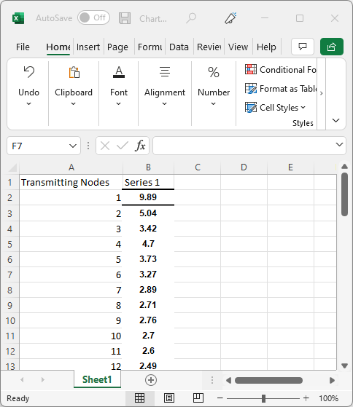

Fig 16: Plot data

1. This will provide a scatter plot. Now edit the Axis Titles to Average Throughput in the Y axis and Number of Transmitting Nodes in the X axis
2. Right click on the x axis and select format axis option. In the Bound section, set the Minimum field to 1.0 and the Maximum field to 50.0. In the Units section, set the Major field to 8.0 and Minor field to 2.0.

Fig 17: Format axis option

1. Enable Trendline in the chart properties. This will provide an Average throughput vs Number of transmitting nodes plot as shown below

Fig 18: Average throughput vs transmitting nodes plot

## **Border effects in line networks: Plotting Throughput vs Transmitting Node ID**

The following steps were done to get the throughput vs transmitting node ID plot:

1. Go to Insert tab and click on chart option, select XY(Scatter) and select Scatter Plot from the options provided. Click on ok.

Fig 19: XY Scatter plot selection

1. In the data sheet, enter the transmitting node ID in the first column and the throughput per application obtained after simulation in the second column. Consider the 5 Transmitting Node scenario.

Fig 20: Plot data

1. This will provide a scatter plot. Now edit the Axis Titles to Throughput in the Y axis and Transmitting Node ID in the X axis
2. Right click on the x axis and select format axis option. In the Bound section, set the Minimum field to 1.0 and the Maximum field to 5.0. In the Units section, set the Major field to 1.0 and Minor field to 0.2.

Fig 21: Format axis option

1. This will provide throughput vs Number of transmitting node ID plot as shown below.
2. Similarly plot for 24 Transmitting Nodes and 49 Transmitting Nodes scenarios.

Fig 22: Throughput vs Transmitting Node ID plot for 5 transmitting nodes, 24 transmitting nodes and 49 transmitting nodes scenarios.

# **Case 3: Ad Hoc Lattice, Single Hop Communication, Two Hop CS Range: Horizontal Traffic**

## **Procedure:**

In this section we explain how users can run the simulation and obtain results that match those provided in the main document

1. Use the following download Link to download a compressed zip folder which contains the workspace: link
2. Extract the zip folder.
3. The extracted project folder consists of a NetSim workspace file (WiFi_Adhoc_Performance_v13

_1.netsimexp).

1. Go to NetSim Home window, go to Your Work and click on Import.

Fig 23: NetSim Home Window

1. In the Import Workspace Window, browse and select the WiFi_Adhoc_Performance_v13_1.netsimexp file from the extracted directory. Click on create a new workspace option and browse to select a path in your system where you want to set up the workspace folder.
2. Choose a suitable name for the workspace of your choice. Click Import.

Fig 24: NetSim Import workspace window

1. The Imported Project workspace will automatically be set as the current workspace.
2. The list of experiments is now loaded onto the selected workspace.
3. The Experiments/ configuration files associated with the case mentioned above are available in the folder“Case_3_Adhoc_Lattice_Single_Hop_Communication_Two_Hop_CS_Range_Horizontal_Traffic” inside the workspace” inside the workspace.

Fig 25: NetSim Your work window with experiments for Case 3- Adhoc Lattice, single hop communication two hop CS Range- Horizontal Traffic

## **Network Scenario**

NetSim UI displays the following Network Scenarios.

Fig 26: Network scenario with $10×10$ MANET nodes. The nearest neighbour distance is 165m. The data transmissions are purely horizontal.

## **Device Coordinates**

The distance setting should be such that the neighbour node is 165m away.

The devices were placed in the following coordinates for each of the cases shown above

|  |  |  |  |  |  |  |
| --- | --- | --- | --- | --- | --- | --- |
| **Node 1** | **Node 2** | **Node 3** | **Node 4** | **Node 5** | $$Node_{i+1}$$ | **Node 324** |
| (0,0) | (165,0) | (330,0) | (495,0) | (660,0) | (x+165, y+165) | (2805,2805) |

Table 13: X and Y coordinates of devices in the network scenario. The devices are placed 165m away from each other.

## **Simulation Parameters**

1. The Grid length was set to .
2. The simulation Parameters were configured as follows:

|  |  |
| --- | --- |
| **802.11 Parameters** | |
| Standard | IEEE802.11g |
| Operating Frequency | 2.4GHz |
| Rate Adaptation | False |
| Dot11_RTS Threshold | 3000B and 1000B |
| Frequency Band | 2.4GHz |
| Bandwidth | 20MHz |
| Transmitter Power | 100mW |
| Medium Access Control | DCF |

Table 14: Values set for different parameters in simulation

|  |  |
| --- | --- |
| **Wireless Link Parameters** | |
| Channel Characteristics | Path Loss Only |
| Path Loss Model | Log Distance |
| Pathloss Exponent (η) | 2.6 |
| Simulation Duration | |
| Simulation Time | 100 seconds |

Table 15: Wireless Link parameter and Simulation time

|  |  |
| --- | --- |
| **Application Parameters** | |
| Application Type | CBR |
| Source ID | $Node_{i}$ where i= 1, 2,…etc 49 |
| Destination ID | where i= 1, 2..etc 49 |
| Packet Size | 1460 bytes |
| Packet Size Distribution | Constant |
| Inter-Arrival Time | 973.33 microseconds  (12 Mbps Application Rate. Saturated queues) and 1460 microseconds (for larger lattices) |
| Transport Protocol | UDP |

Table 16: Application properties set in this experiment

|  |  |
| --- | --- |
| **Protocol Parameters** | **Value** |
| CS Threshold | -85 dBm |
| SIFS | 10 $μs$ |
| Slot Time | 9 $μs$ |
| DIFS (SIFS + $2×$ Slot Time) | 28 $μs$ |
| Preamble Time | 20 $μs$ |
| MPDU Size | 1528 B |

Table 17: 802.11 g protocol parameters. These values are set in the code

## **Static Route configuration**

Static routes were configured in each device so that the flow of data packets will be transmitted from Node i to Node i+1

To set the static routes, go to Wireless_Node properties > Network Layer > Enable Static Route IP.

|  |  |  |  |  |  |
| --- | --- | --- | --- | --- | --- |
| **Device** | **Network Destination** | **Gateway** | **Subnet Mask** | **Metrics** | **Interface ID** |
| Wireless_Node_1 | 11.1.1.2 | 11.1.1.2 | 255.255.255.255 | 1 | 1 |
| Wireless_Node_2 | 11.1.1.3 | 11.1.1.3 | 255.255.255.255 | 1 | 1 |
| Wireless_Node_3 | 11.1.1.4 | 11.1.1.4 | 255.255.255.255 | 1 | 1 |
| Wireless_Node $i+1$_ | 11.1.1.(i+1) | 11.1.1.(i+1) | 255.255.255.255 | 1 | 1 |

Table 18: Static route configured for Case 3.

## **Results**

The average and aggregate application throughput is noted down from the NetSim Results window and tabulated in Table 10 of the main document.

Steps to calculate the average and aggregate throughput are as follows:

1. Run the simulation for cases with different lattice sizes.
2. After the simulation note down the application throughputs (for each application), copy the values into an Excel sheet.
3. Calculate the Average and Aggregate throughputs for each case and tabulate the data.

Fig 27: Average and aggregate throughput calculation for each case with lattice size varying from $2×2$ to $18×18$

## **Plotting Average Throughput vs Number of Transmitting Nodes**

The following steps were done to get the average throughput vs Number of transmitting nodes plot:

1. Go to Insert tab and click on chart option, select XY(Scatter) and select Scatter Plot from the options provided. Click on ok

Fig 28: XY Scatter plot selection

1. In the data sheet, enter the Number of Transmitting nodes in the first column (x values) and average throughput obtained in the second column (Y values).

Fig 29: Plot data

1. This will provide a scatter plot. Now edit the Axis Titles to Average Throughput in the Y axis and Number of Transmitting Nodes in the X axis
2. Right click on the x axis and select format axis option. In the Bound section, set the Minimum field to 0 and the Maximum field to 350.0. In the Units section, set the Major field to 50.0 and Minor field to 10.0.

Fig 30: Format axis option

1. Enable Trendline in the chart properties. This will provide an Average throughput vs Number of transmitting nodes plot as shown below

Fig 31: Average throughput vs transmitting nodes plot

# **Case 4: 4 Hop Network**

In this section we explain how users can run the simulation and obtain results that match those provided in the main document.

Users have two options for running these simulations.

* Using the NetSim GUI. In this case the simulation will need to open one-by-one in NetSim and then run. The process is time consuming but is useful initially to get an understanding of the network the parameters configured and the results
* Using the Multi-parameter sweeper utility. With this user can sweep one or more parameters, change their values between simulation runs, and compare and analyse the performance metrics from each run. The entire process changing the values, running simulations, and collating results is done automatically by this utility.

The first sub section below explains how users can run simulations via the GUI while the next explains how to use the multi-parameter sweeper.

## **Using NetSim’s GUI. Importing the project into NetSim.**

1. Download a compressed zip folder which contains the NetSim workspace from link
2. The extracted project folder would have a NetSim workspace file Performance-Analysis-Wireless-Adhoc-network.netsimexp.
3. Go to NetSim Home window, go to Your Work and click on Import.

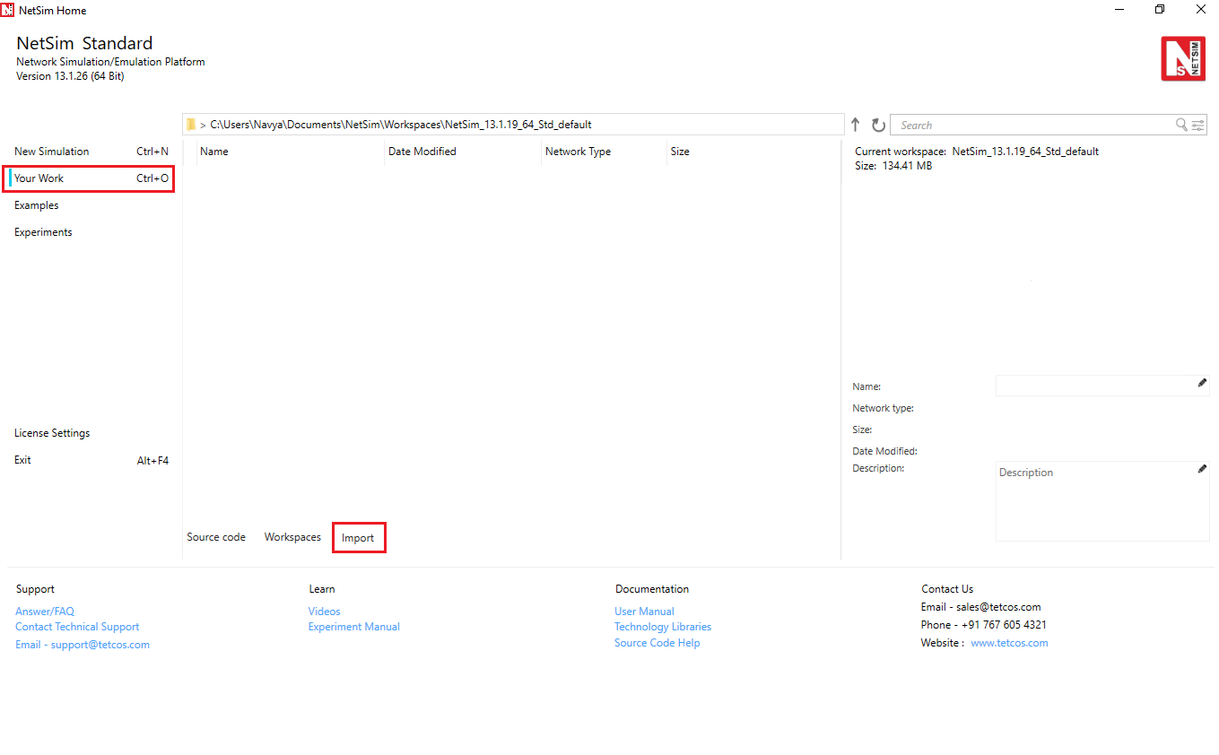

Fig 32:NetSim Home page window

1. In the Import Workspace Window, browse and select the Performance-Analysis-Wireless-Adhoc-network.netsimexp file from the extracted directory. Click on create a new workspace option. Browse to select a path where you want to have the workspace folder.
2. Choose a suitable name for the workspace. Click Import

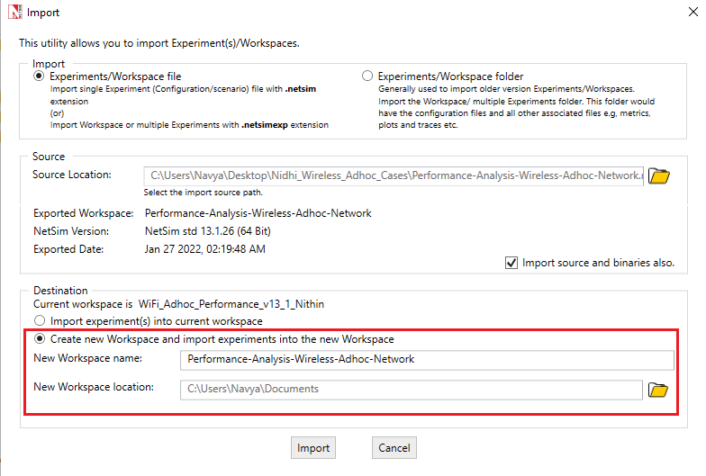

Fig 33: Importing workspace into new workspace

1. The Imported Project workspace will automatically be set as the current workspace. The list of experiments is now loaded onto the selected workspace.
2. The screen shot below shows the folder/file organization for 4-hop, 5-hop, 6-hop and 7-hop network scenarios.

Fig 34:Folder with 4-Hop, 5- Hop, 6-Hop and 7-Hop (With RTS-CTS) examples

## **Simulation Parameters**

1. Grid length of 1500m × 1500m

|  |  |  |
| --- | --- | --- |
| **Devices** | **X** | **Y** |
| Wireless_Node_1 | 0 | 300 |
| Wireless_Node_2 | 300 | 300 |
| Wireless_Node_3 | 600 | 300 |
| Wireless_Node_4 | 900 | 300 |
| Wireless_Node_5 | 1200 | 300 |

Table 19: X and Y coordinates of devices in the network scenario

1. The designed in NetSim’s MANET library. It comprises of Wireless nodes connected via an Adhoc link.

Fig 35: Network Scenario for 4-Hop Network designed with 5 wireless nodes

1. Device properties are set as shown below

|  |  |  |  |  |  |  |  |  |  |  |  |  |  |  |  |  |  |  |  |  |  |  |  |  |  |  |  |  |  |  |  |  |  |  |  |  |  |  |  |  |  |  |  |  |  |  |  |  |  |
| --- | --- | --- | --- | --- | --- | --- | --- | --- | --- | --- | --- | --- | --- | --- | --- | --- | --- | --- | --- | --- | --- | --- | --- | --- | --- | --- | --- | --- | --- | --- | --- | --- | --- | --- | --- | --- | --- | --- | --- | --- | --- | --- | --- | --- | --- | --- | --- | --- | --- |
| Table 20: Wireless Node 802.11 parameters   |  |  | | --- | --- | | **802.11 properties** | | | **Physical layer** | | | Standard | 802.11b | | Operating frequency | 2.4GHz | | Transmitter Power | 100mW | | Transmission type | DSSS | | Power Source | Main | | **Datalink layer** |  | | Rate Adaptation | False | | Media Access protocol | DCF | | Dot11_RTS Threshold | 3000bytes |  |  |  | | --- | --- | | **General Properties** | | | Mobility Model | No Mobility |   Table 21: Wireless general properties  The interpacket arrival time is computed as shown below | |  |  | | --- | --- | | **Wireless link Properties** | | | Channel Characteristics | Path Loss Only | | Path Loss Model | Log Distance | | Pathloss Exponent (η) | 2.6 |  |  |  | | --- | --- | | **Application properties** | | | Application type | CBR | | Source ID | Wireless_Node_1 | | Destination ID | Wireless_Node_5 | | Transport layer protocol | UDP | | Packet Size | 1000 bytes | | Generation Rate/ Inter arrival time | Varied as shown in Table 24 |   Table 22: Wireless Link Parameters  Table 23: Application properties |

$$Inter\left(packet\right)ArrivalTime \left(μs\right)= \frac{PacketSize×8}{GenerationRate (Mbps)}$$

## **Static Route Configuration**

Static routes (whereby N_i always transmits to N_(i+1)) are set to ensure single hop transmission. Thereby each node transmits data to the next-hop node according to the topology

To set Static routes for wireless nodes in order to transmit the data from Wireless_Node_1> Wireless_Node_2>Wireless_Node_3>Wireless_Node_4>Wireless_Node_5

Go to Wireless Nodes > Network layer >Enable Static IP Route and configure as below

**Wireless_Node_1**:

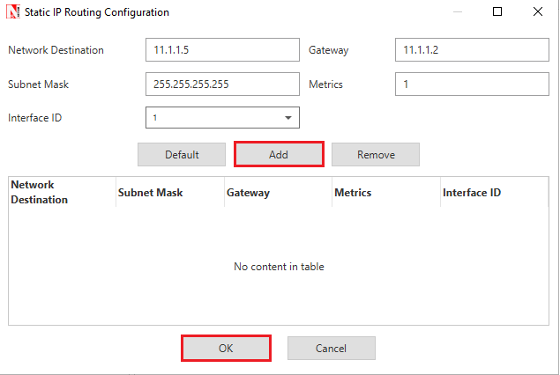

Fig 36: Static Route Configuration for Source node

Click on Add and then OK to set static routes in wireless node

Similarly configure for static routes for the remaining wireless nodes

|  |  |  |  |  |  |
| --- | --- | --- | --- | --- | --- |
| **Device** | **Network Destination** | **Gateway** | **Subnet Mask** | **Metrics** | **Interface ID** |
| Wireless_node_2 | 11.1.1.5 | 11.1.1.3 | 255.255.255.255 | 1 | 1 |
| Wireless_node_3 | 11.1.1.5 | 11.1.1.4 | 255.255.255.255 | 1 | 1 |
| Wireless_node_4 | 11.1.1.5 | 11.1.1.5 | 255.255.255.255 | 1 | 1 |

Run the simulation for 100 sec and tabulate the throughput

## **Numerical Results**

The following data is used to generate the plot.

|  |  |  |
| --- | --- | --- |
| **Generation Rate (Mbps)** | **IAT (µs)** | **Throughput (Mbps)** |
| 0.05 | 160000 | 0.050021 |
| 0.1 | 80000 | 0.100042 |
| 0.15 | 53333 | 0.149979 |
| 0.2 | 40000 | 0.2 |
| 0.25 | 32000 | 0.250021 |
| 0.3 | 26666 | 0.299958 |
| 0.35 | 22857 | 0.349979 |
| 0.4 | 20000 | 0.399916 |
| 0.45 | 17777 | 0.449937 |
| 0.5 | 16000 | 0.499958 |
| 0.51 | 15686 | 0.509979 |
| 0.52 | 15384 | 0.519916 |
| 0.53 | 15094 | 0.492968 |
| 0.54 | 14814 | 0.471832 |
| 0.55 | 14545 | 0.460042 |
| 0.56 | 14285 | 0.447326 |
| 0.57 | 14035 | 0.434863 |
| 0.58 | 13793 | 0.420126 |
| 0.59 | 13559 | 0.420968 |
| 0.6 | 13333 | 0.416337 |
| 0.65 | 12307 | 0.410189 |
| 0.7 | 11428 | 0.404379 |
| 0.75 | 10666 | 0.3952 |
| 0.8 | 10000 | 0.3872 |
| 0.85 | 9411 | 0.379453 |
| 0.9 | 8888 | 0.376168 |
| 0.95 | 8421 | 0.372968 |
| 1 | 8000 | 0.378442 |
|  |  |  |

Table 24:Numerical results for 4-Hop Network

# **Automated simulation using multi-parameter sweeper**

1. Here we run the samples for the same example mentioned above using the multi parameter sweeper
2. We use a base (first) network configuration file with packet size as 1000 bytes and Inter arrival time as 160000 µs. This gives a traffic generation rate of 0.05 Mbps.
3. The Multi parameter has been configured to run the multiple scenarios (one after the other sequentially) with Inter-arrival times varying in the steps of 0.05 Mbps.

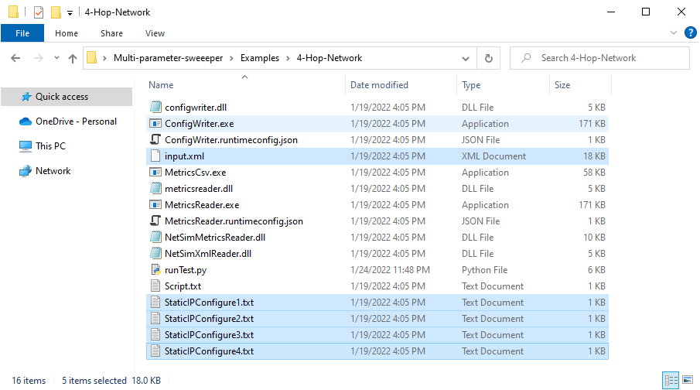

Fig 37:Multi Parameter sweeper folder consists of input.xml and several binaries

## **Changes done to the config file to run the Multi-Parameter sweeper**

1. Users can skip this sub section if they only wish to run simulations. In this sub section we explain the changes done to run the sweeper. It would be beneficial to users who wish to run the sweeper for other scenarios.
2. The Configuration.netsim and Static Route Configuration text files are copied from the saved experiment folder to Multi-parameter sweeper folder. Configuration.netsim is renamed as input.xml
3. The value of Inter_Arrival_time has been modified during each simulation is updated to {0} in the Configuration.netsim as shown below

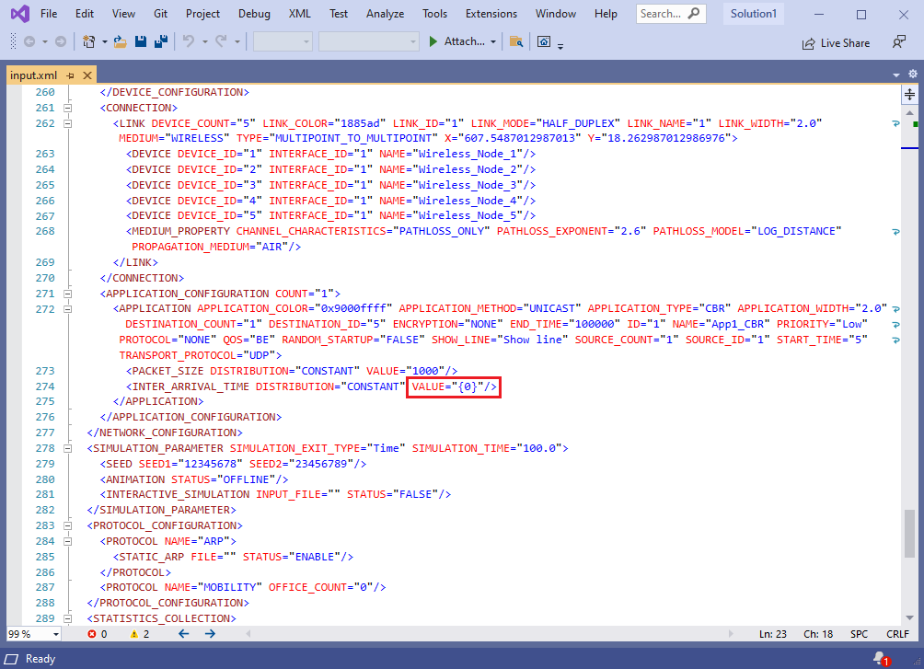

Fig 38: Modified Inter arrival time value in input.xml

1. The MP sweeper collates the results of the different simulation runs into a single XL file. How is this done? The Script.txt file (available in MP sweeper folder) is updated with the details of the output parameter to be read from the Metrics.xml file. After each run it is this output parameter’s value that is added to the result csv log file.
2. In this example it the Application Throughput that we wish to log for each simulation run.
3. runTest.py is updated to (i) pass different inter-arrival values during each iteration (ii) generate configuration files (iii) run simulation and (iv) update the result csv log.

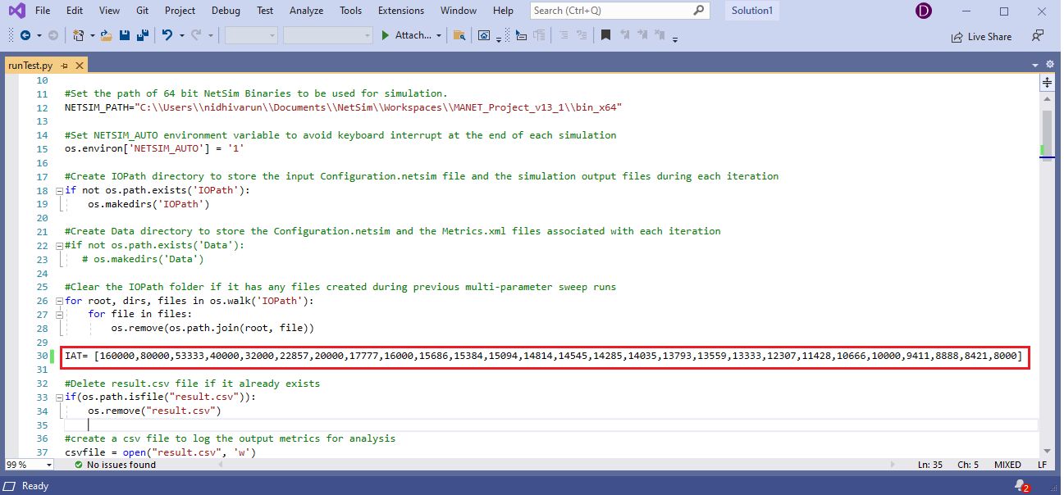

Fig 39: Varied Inter arrival time in runTest.py

1. NetSim_Path variable is set to the workspace directory and to this bin_x64 is appended. An example is shown in the screen shot below.

Fig 40: NetSim Path is set with x64 bit code modified workspace

1. Number of nodes used in Network scenario is given to copy the Static Route Configuration text files to IO path same as Configuration.netsim

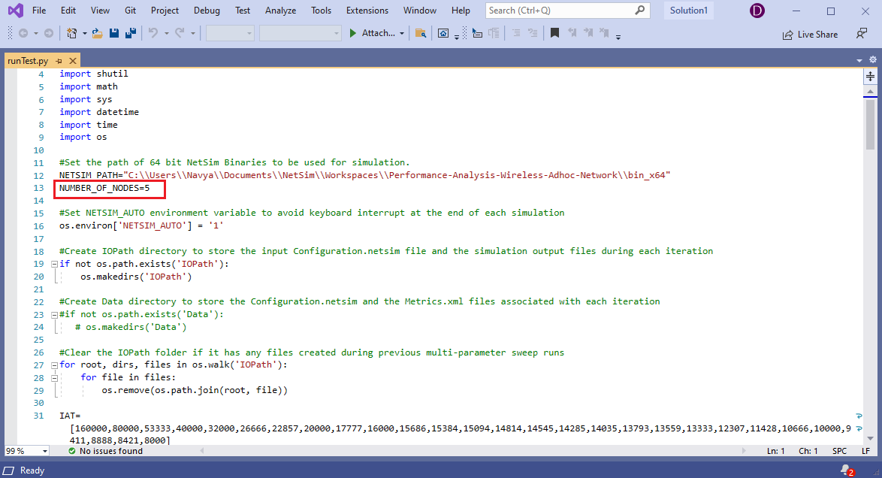

Fig 41:Number of nodes in scenario is given as input to copy the Static route configuration files to IO path

1. Modify the license Path in runTest.py file

* If you are using server node locked or dongle based floating license

cmd="start \"NetSim_Multi_Parameter_Sweeper\" /wait /min /d "+ "\""+NETSIM_PATH+ "\" "\ +"NetSimcore.exe -apppath \""+NETSIM_PATH+"\" -iopath \""+strIOPATH+\ "\" -license <Your Server IP Address>"

* If you are using client node locked evaluation license or cloud license

cmd="start \"NetSim_Multi_Parameter_Sweeper\" /wait /min /d "+ "\""+NETSIM_PATH+ "\" "\ +"NetSimcore.exe -apppath \""+NETSIM_PATH+"\" -iopath \""+strIOPATH+\"\ -license "+"\"<Your install directory>””

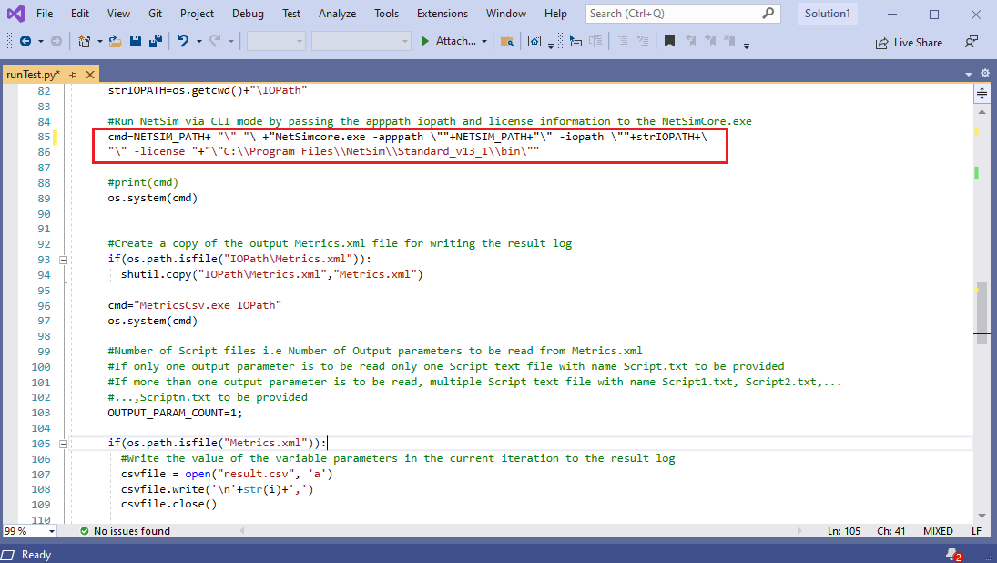

Fig 42: License path is set based on node locked evaluation license / cloud license/ server node locked/dongle based floating license

1. The sweeper process is started by opening command prompt in the directory of the Multi-Parameter-Sweeper project and starting the python script as shown below

Fig 43: Running python script using cmd prompt

1. Then the Multi-Parameter-Sweeping process which runs NetSim simulations iteratively for different values of Inter Arrival time.

## **Results**

Upon completing all the simulations, the Multi-Parameter-Sweeping folder will have the following file and folders created as shown below

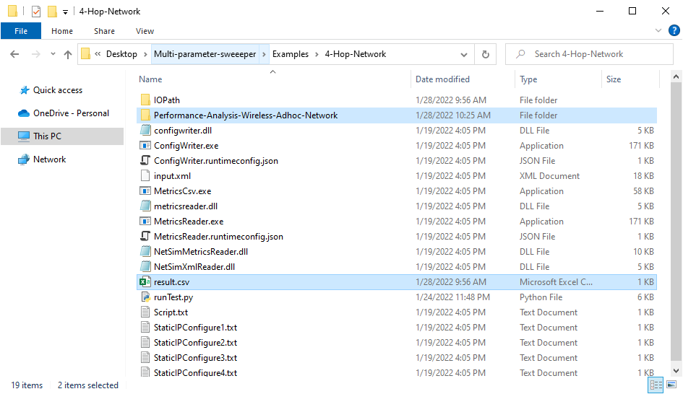

Fig 44: After Simulation Multi-Parameter-Sweeping folder contains output files like result.scv, Folders consists of related network cases

**Performance-Analysis-Wireless-Adhoc-Network**: Contains multiple folders corresponding to each simulation run. The file name has the value of the parameter used in that iteration

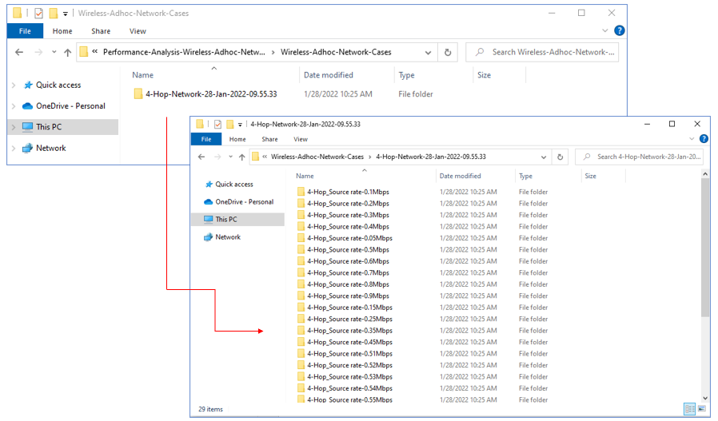

Fig 45:Based on Source rate/Different Inter arrival time Configuration files are created

Each folder contains the all the output files associated with each simulation run

Fig 46: Each folder contains the all the output files

**Result.csv**: This is the output log which contains the Inter Arrival time varied during each simulation run and the corresponding throughput after each run.

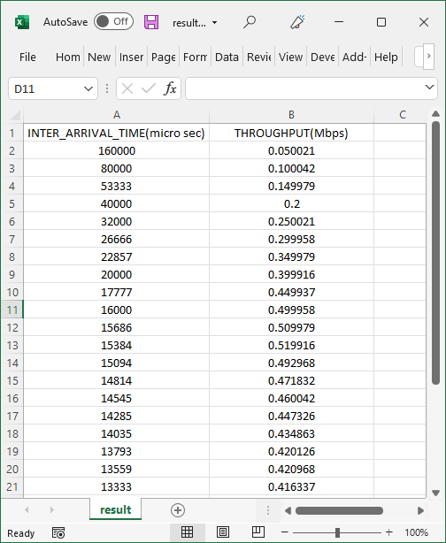

Fig 47:Throughput (Mbps) obtained for different value of IAT in result.csv

# **Case 5: 5 Hop Network**

1. In the imported workspace, go to 5-Hop Network folder to display the related 5-Hop cases.
2. This designed in NetSim’s MANET library. It comprises of 6 Wireless nodes connected via an Adhoc link and the Application is created between Source ID Wireless_Node_1 and destination ID Wireless_Node_6.

Fig 48: Network Scenario for 5-Hop Network designed with 6 wireless nodes

1. The Simulation parameters setting remains the same as previous case

## **Additional Setting**

1. Grid length of 1500m × 1500m

|  |  |  |
| --- | --- | --- |
| **Devices** | **X** | **Y** |
| Wireless_Node_1 | 0 | 300 |
| Wireless_Node_2 | 300 | 300 |
| Wireless_Node_3 | 600 | 300 |
| Wireless_Node_4 | 900 | 300 |
| Wireless_Node_5 | 1200 | 300 |
| Wireless_Node_6 | 1500 | 300 |

Table 25: X and Y Co- ordinates of devices for 5-Hop Network

1. Static route should be carefully configured to ensure the data flow from Wireless_Node_1>Wireless_Node_2> Wireless_Node_3> Wireless_Node_4> Wireless_Node_5> Wireless_Node_6

## **Numerical Results**

The following data is used to generate the plot.

|  |  |  |
| --- | --- | --- |
| **Generation Rate (Mbps)** | **IAT (µs)** | **Throughput (Mbps)** |
| 0.05 | 160000 | 0.050021 |
| 0.1 | 80000 | 0.100042 |
| 0.15 | 53333 | 0.149979 |
| 0.2 | 40000 | 0.2 |
| 0.25 | 32000 | 0.249937 |
| 0.3 | 26666 | 0.299958 |
| 0.35 | 22857 | 0.349979 |
| 0.4 | 20000 | 0.399916 |
| 0.45 | 17777 | 0.449937 |
| 0.5 | 16000 | 0.499874 |
| 0.51 | 15686 | 0.509895 |
| 0.52 | 15384 | 0.519916 |
| 0.53 | 15094 | 0.483705 |
| 0.54 | 14814 | 0.463411 |
| 0.55 | 14545 | 0.450442 |
| 0.56 | 14285 | 0.433179 |
| 0.57 | 14035 | 0.421305 |
| 0.58 | 13793 | 0.406063 |
| 0.59 | 13559 | 0.392084 |
| 0.6 | 13333 | 0.376168 |
| 0.65 | 12307 | 0.357811 |
| 0.7 | 11428 | 0.346779 |
| 0.75 | 10666 | 0.345684 |
| 0.8 | 10000 | 0.332379 |
| 0.85 | 9411 | 0.334905 |
| 0.9 | 8888 | 0.327663 |
| 0.95 | 8421 | 0.329937 |
| 1 | 8000 | 0.331705 |

Table 26: Numerical results for 5-Hop Network

## **Changes done to the config file to run the multi-Parameter sweeper**

1. The Configuration file saved with above setting is replaced in the Multi parameter folder and Inter arrival time value mentioned as {0}
2. Number of nodes used in Network scenario is given to copy the Static Route Configuration text files to IO path same as Configuration.netsim

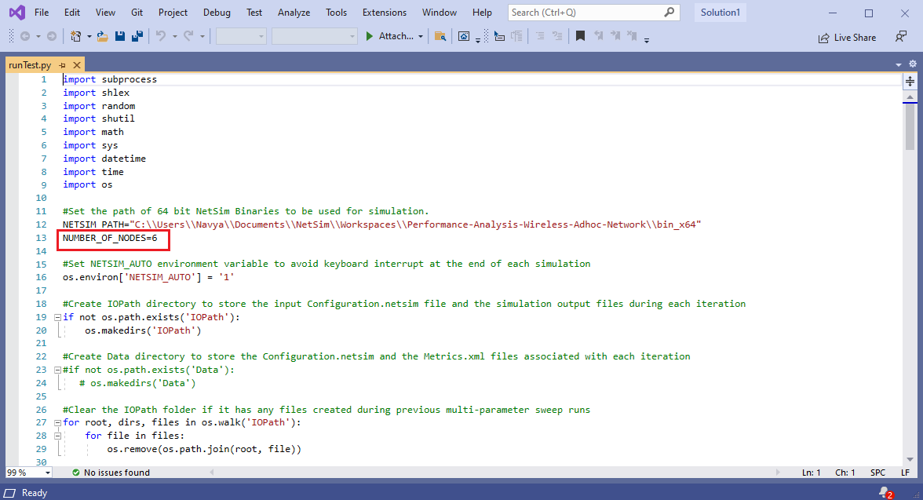

Fig 49: Number of nodes in scenario is given as input to copy the Static route configuration files to IO path

1. If the user wishes to change the output folder name, it can be renamed as 5-Hop as in shown in

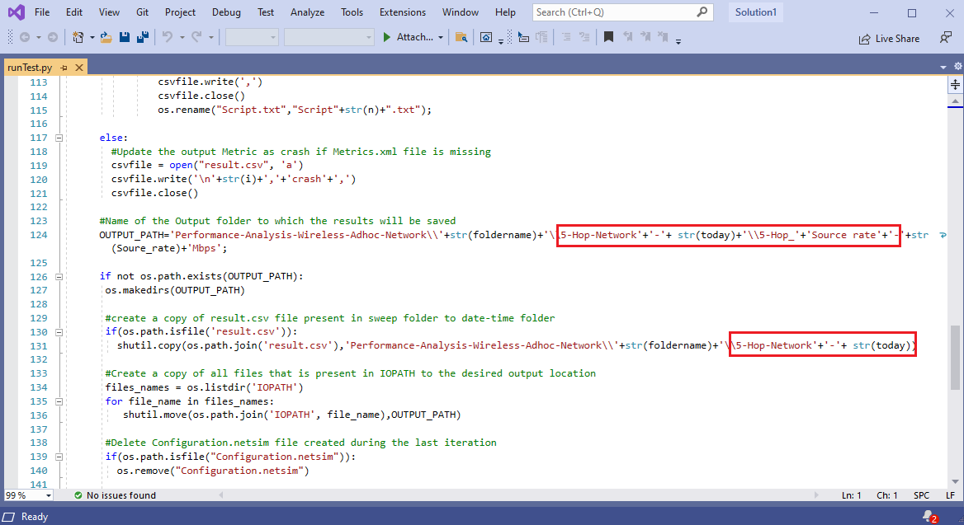

Fig 50:Renaming the output folder by Number of Hops

1. The sweeper process is started by opening command prompt in the directory of the Multi-Parameter-Sweeper project.
2. Then the Multi-Parameter-Sweeping process which runs NetSim simulations iteratively for different values of Inter Arrival time and provides the results in results.csv file as shown in below

Fig 51: 5-Hop Network results

# **Case 06: 6- Hop Network**

1. In the imported workspace, go to 6-Hop Network folder to display the related 6-Hop cases.
2. This designed in NetSim’s MANET library. It comprises of 7 Wireless nodes connected via an Adhoc link and the Application is created between Source ID Wireless_Node_1 and destination ID Wireless_Node_7.

Fig 52: Network Scenario for 6-Hop Network designed with 7 wireless nodes

1. The Simulation parameters setting remains the same as previous case

## **Additional Setting**

1. Grid length is 2000m × 2000m, Place the devices 300m apart from one another.

|  |  |  |
| --- | --- | --- |
| **Devices** | **X** | **Y** |
| Wireless_Node_1 | 0 | 300 |
| Wireless_Node_2 | 300 | 300 |
| Wireless_Node_3 | 600 | 300 |
| Wireless_Node_4 | 900 | 300 |
| Wireless_Node_5 | 1200 | 300 |
| Wireless_Node_6 | 1500 | 300 |
| Wireless_Node_7 | 1800 | 300 |

Table 27: X and Y Co- ordinates of devices for 6-Hop Network

1. Static route should be carefully configured to ensure the data flow from Wireless_Node_1>Wireless_Node_2>Wireless_Node_3> Wireless_Node_4> Wireless_Node_5> Wireless_Node_6>Wireless_Node_7.
2. Run the simulation for 100 sec and tabulate the throughput.

## **Numerical Results**

The following data is used to generate the plot.

|  |  |  |
| --- | --- | --- |
| **Generation Rate (Mbps)** | **IAT (µs)** | **Throughput (Mbps)** |
| 0.05 | 160000 | 0.050021 |
| 0.1 | 80000 | 0.100042 |
| 0.15 | 53333 | 0.149979 |
| 0.2 | 40000 | 0.2 |
| 0.25 | 32000 | 0.249937 |
| 0.3 | 26666 | 0.299958 |
| 0.35 | 22857 | 0.349895 |
| 0.4 | 20000 | 0.399916 |
| 0.45 | 17777 | 0.449937 |
| 0.5 | 16000 | 0.499874 |
| 0.51 | 15686 | 0.453642 |
| 0.52 | 15384 | 0.438232 |
| 0.53 | 15094 | 0.426442 |
| 0.54 | 14814 | 0.415579 |
| 0.55 | 14545 | 0.407411 |
| 0.56 | 14285 | 0.393347 |
| 0.57 | 14035 | 0.383242 |
| 0.58 | 13793 | 0.366905 |
| 0.59 | 13559 | 0.354442 |
| 0.6 | 13333 | 0.340884 |
| 0.65 | 12307 | 0.336926 |
| 0.7 | 11428 | 0.332884 |
| 0.75 | 10666 | 0.320084 |
| 0.8 | 10000 | 0.310063 |
| 0.85 | 9411 | 0.312084 |
| 0.9 | 8888 | 0.309389 |
| 0.95 | 8421 | 0.308716 |
| 1 | 8000 | 0.310484 |

Table 28: Numerical results for 6-Hop Network

## **Changes done to the config file to run the multi-Parameter sweeper**

1. The Configuration file saved with above setting is replaced in the Multi parameter folder and Inter arrival time value mentioned as {0}
2. Number of nodes used in Network scenario is given to copy the Static Route Configuration text files to IO path same as Configuration.netsim

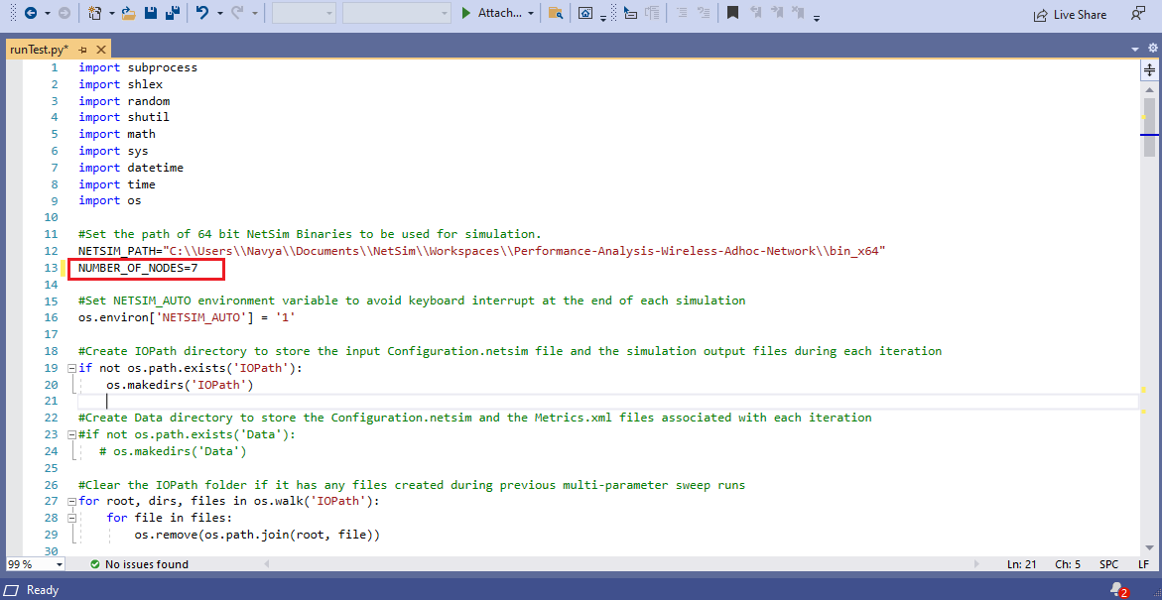

Fig 53: Number of nodes in scenario is given as input to copy the Static route configuration files to IO path

1. If the user wishes to change the output folder name, it can be renamed as 6-Hop.

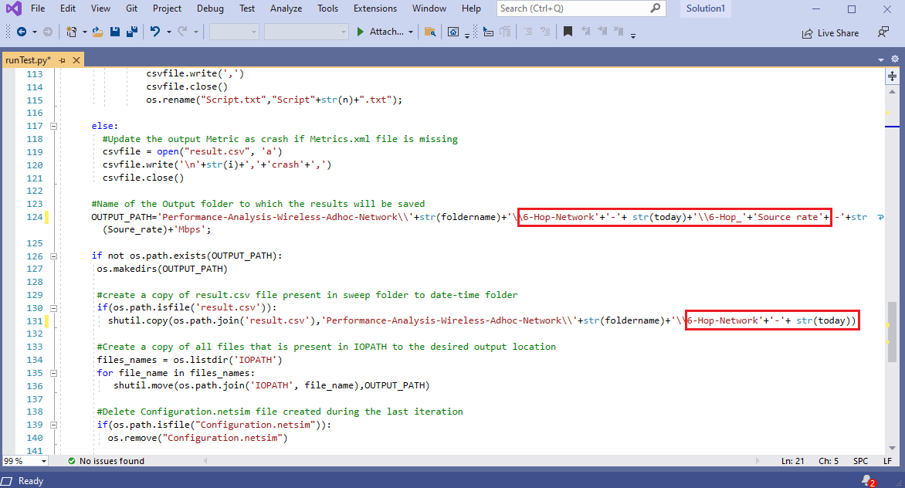

Fig 54:Renaming the Output folder by Number of Hop count

1. The sweeper process is started by opening command prompt in the directory of the Multi-Parameter-Sweeper project.
2. Then the Multi-Parameter-Sweeping process which runs NetSim simulations iteratively for different values of Inter Arrival time and provides the results in results.csv file as shown in below

Fig 55: 6-Hop Network results

# **Case 07: 7-Hop Network**

1. In the imported workspace, go to 7-Hop Network folder to display the related 7-Hop cases.
2. This designed in NetSim’s MANET library. It comprises of 8 Wireless nodes connected via an Adhoc link and the Application is created between Source ID Wireless_Node_1 and destination ID Wireless_Node_8**.**

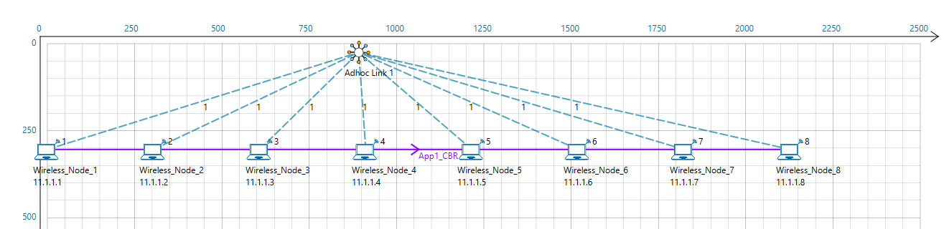

Fig 56: Network Scenario for 7-Hop Network designed with 8 wireless nodes

1. The Simulation parameters setting remains the same as previous case

## **Additional Setting**

1. Grid length 2500m ×2500m

|  |  |  |
| --- | --- | --- |
| **Devices** | **X** | **Y** |
| Wireless_Node_1 | 0 | 300 |
| Wireless_Node_2 | 300 | 300 |
| Wireless_Node_3 | 600 | 300 |
| Wireless_Node_4 | 900 | 300 |
| Wireless_Node_5 | 1200 | 300 |
| Wireless_Node_6 | 1500 | 300 |
| Wireless_Node_7 | 1800 | 300 |
| Wireless_Node_8 | 2100 | 300 |

Table 29: X and Y Co- ordinates of devices for 7-Hop Network

1. Static route should be carefully configured to ensure the data flow from Wireless_Node_1>Wireless_Node_2>Wireless_Node_3> Wireless_Node_4> Wireless_Node_5> Wireless_Node_6>Wireless_Node_7>Wireless_Node_8
2. Dot11_RTS Threshold value is changed to 750 bytes in all wireless nodes.
3. Run the simulation for 100 sec and tabulate the throughput.

## **Numerical Results**

The following data is used to generate the plot.

|  |  |  |
| --- | --- | --- |
| **Generation Rate (Mbps)** | **IAT (µs)** | **Throughput (Mbps)** |
| 0.05 | 160000 | 0.050021 |
| 0.1 | 80000 | 0.100042 |
| 0.15 | 53333 | 0.149979 |
| 0.2 | 40000 | 0.2 |
| 0.25 | 32000 | 0.250189 |
| 0.3 | 26666 | 0.300042 |
| 0.35 | 22857 | 0.327074 |
| 0.4 | 20000 | 0.313432 |
| 0.45 | 17777 | 0.310989 |
| 0.5 | 16000 | 0.274611 |
| 0.51 | 15686 | 0.265768 |
| 0.52 | 15384 | 0.255411 |
| 0.53 | 15094 | 0.244632 |
| 0.54 | 14814 | 0.244042 |
| 0.55 | 14545 | 0.244126 |
| 0.56 | 14285 | 0.235368 |
| 0.57 | 14035 | 0.235621 |
| 0.58 | 13793 | 0.235705 |
| 0.59 | 13559 | 0.236716 |
| 0.6 | 13333 | 0.226947 |
| 0.65 | 12307 | 0.217768 |
| 0.7 | 11428 | 0.221558 |
| 0.75 | 10666 | 0.227958 |
| 0.8 | 10000 | 0.215832 |
| 0.85 | 9411 | 0.2224 |
| 0.9 | 8888 | 0.223495 |
| 0.95 | 8421 | 0.234442 |
| 1 | 8000 | 0.220042 |

Table 30: Numerical results for 7-Hop Network

# **Changes done to the config file to run the multi-Parameter sweeper**

1. The Configuration file saved with above setting is replaced in the Multi parameter folder and Inter arrival time value mentioned as {0}
2. Number of nodes used in Network scenario is given to copy the Static Route Configuration text files to IO path same as Configuration.netsim

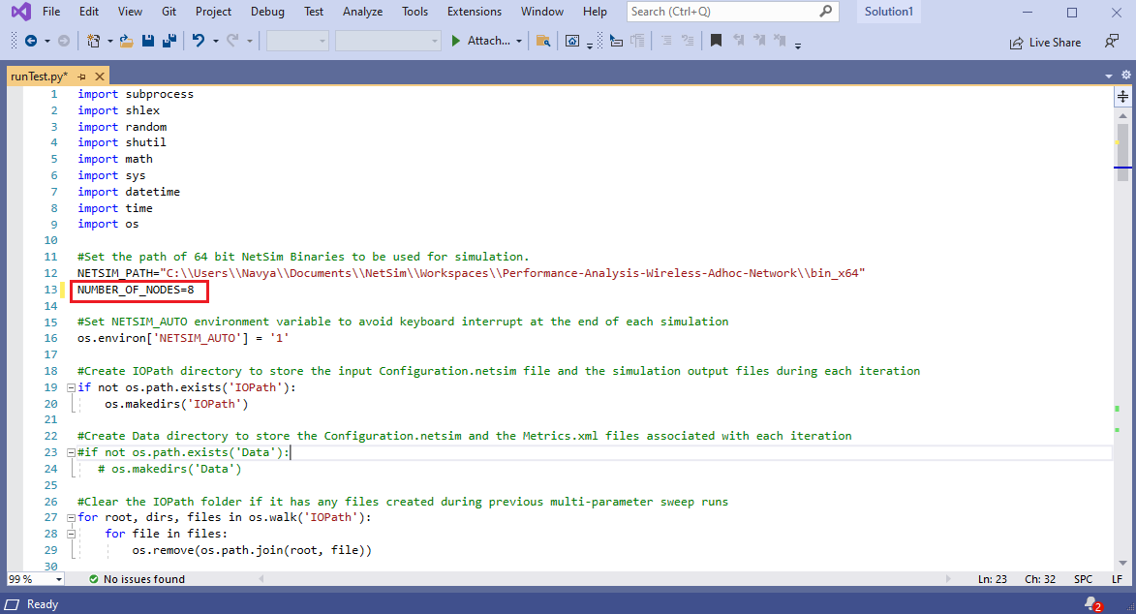

Fig 57: Number of nodes in scenario is given as input to copy the Static route configuration files to IO path

1. If the user wishes to change the output folder name, it can be renamed as 7-Hop.

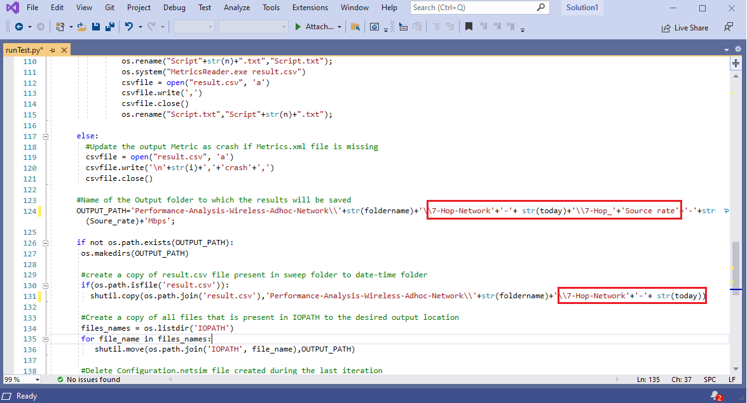

Fig 58: Renaming the output folder by Number of Hop count

1. The sweeper process is started by opening command prompt in the directory of the Multi-Parameter-Sweeper project.
2. Then the Multi-Parameter-Sweeping process which runs NetSim simulations iteratively for different values of Inter Arrival time and provides the results in results.csv file as shown in below

Fig 59: 7-Hop network results

# **Appendix**

## **Source code modifications involving in Case 1, Case 2, Case 3.**

The workspace was modified with the following code changes:

1. The **CSRANGEDIFF** variable was set to -8 dB in the IEEE802_11_Phy.h file present in the IEEE802_11 project.
2. The following lines of code were commented in the IEEE802_11.h file present in the IEEE802_11 project.

**#define _RECALCULATE_RX_SENSITIVITY_BASED_ON_PEP_**

To modify the source code, the steps given below are to be followed:

1. Open NetSim source codes via Your Work > Source Code > Open Code option

Fig 60: NetSim Open Code option

1. This will open the NetSim Source codes in Visual Studio as shown below:

Fig 61: NetSim source codes in Visual Studio

1. Go to IEEE802_11_Phy.h file in the IEEE802_11 project. In the line #42, the CSRANGEDIFF was set to -8 dB.

Fig 62: Code modification done in IEEE802_11_Phy.h file

1. Go to IEEE802_11.h file in the IEEE802_11 project and comment the line #38 as shown below

Fig 63: Code modification done in IEEE802_11.h file

1. Right click on the IEEE802_11 project in the solution Explorer and click on Rebuild.

Fig 64: Rebuild code option

1. Upon a successful build, the dll in the binaries folder of the current workspace will automatically get updated.

## **Source code modifications involving in Case 4, Case 5, Case 6, Case 7**

The workspace was modified with the following code changes:

1. The **CSRANGEDIFF** variable was set to -3 dB in the IEEE802_11_Phy.h file present in the IEEE802_11 project.
2. The following lines of code were commented in the IEEE802_11.h file present in the IEEE802_11 project.

**#Define_RECALCULATE_RX_SENSITIVITY_BASED_ON_PEP_**

To modify the source code, the steps given below are to be followed:

1. Open NetSim source codes via Your Work > Source Code > Open Code option

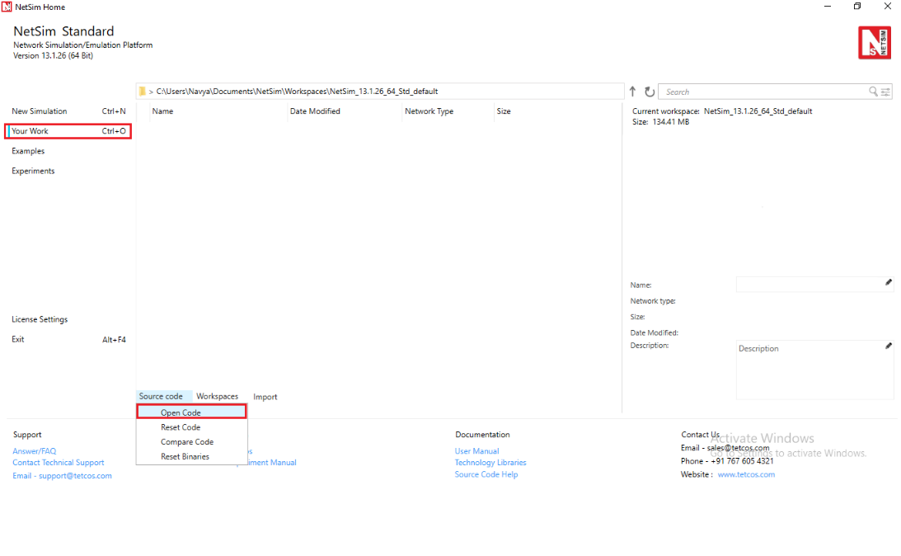

Fig 65: NetSim Open Code option

1. This will open the NetSim Source codes in Visual Studio as shown below:

Fig 66: NetSim Source code in Visual Studios

1. Go to IEEE802_11_Phy.h file inside the IEEE802_11 project. Modifythe CSRANGEDIFF to -3 dB in line #42.

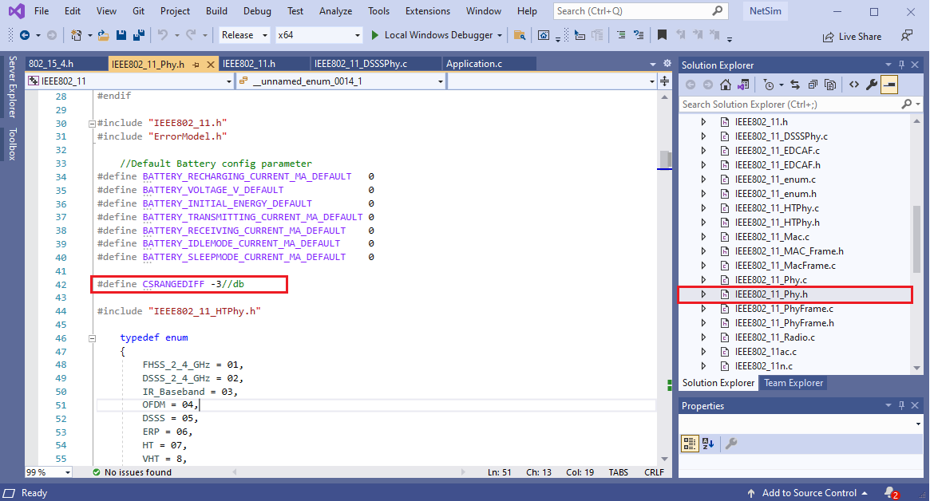

Fig 67: Code modification done in IEEE802_11_Phy.h file

1. Go to IEEE802_11.h file in the IEEE802_11 project and comment the line #38 as shown below

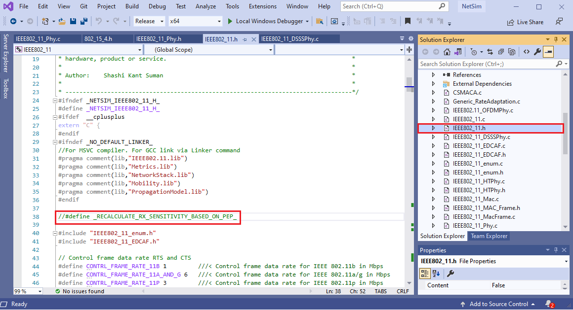

Fig 68: Code modification done in IEEE802_11.h file

1. In IEEE802_11_DSSSPhy.c, Receiver sensitivity is set to -87 dBm for 2Mbps in line#44

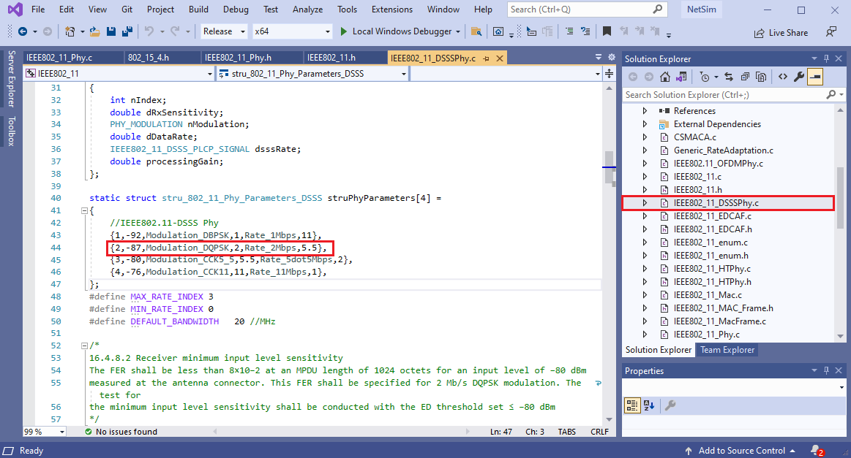

Fig 69: Code modification done in IEEE802_11_DSSSPhy.c file

1. Right click on the IEEE802_11 project in the solution Explorer and click on Rebuild

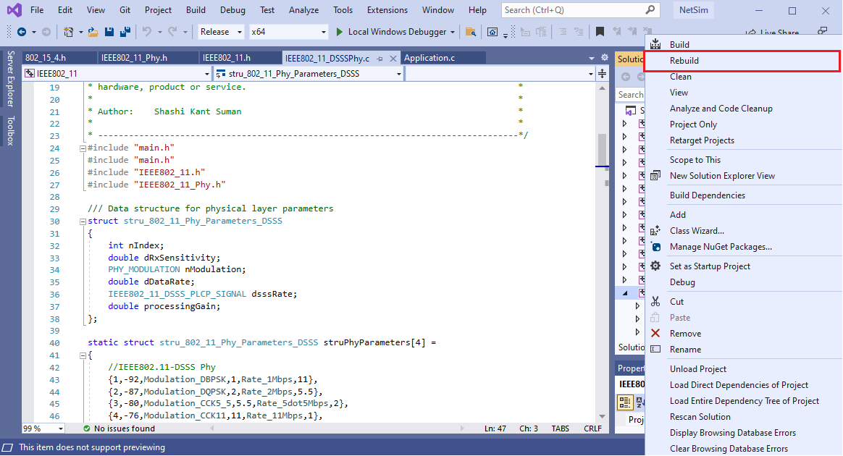

Fig 70: Rebuild 802.11project

1. Upon a successful build, the dll in the binaries folder of the current workspace will automatically get updated.